# Assignment 1

# Create the required Lambda function

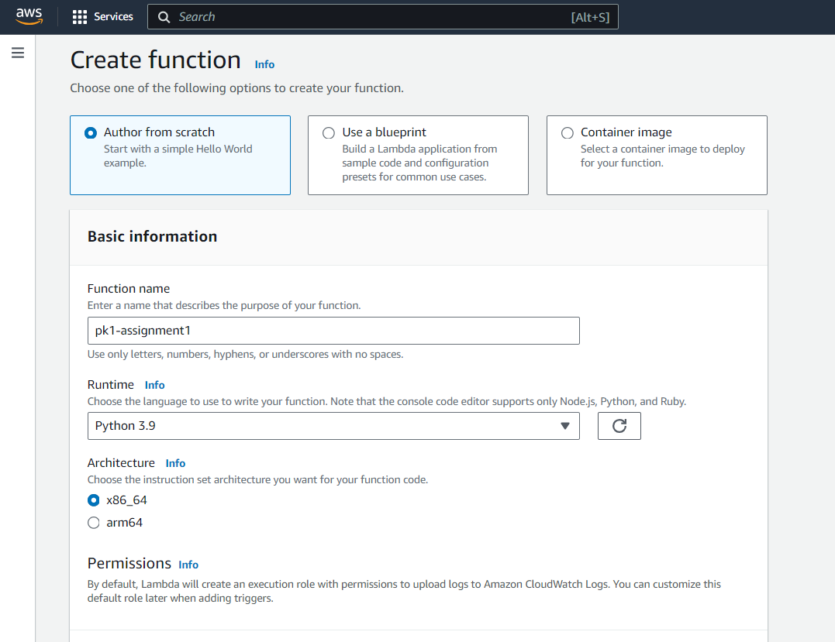

# Use an existing Ec2 full access role

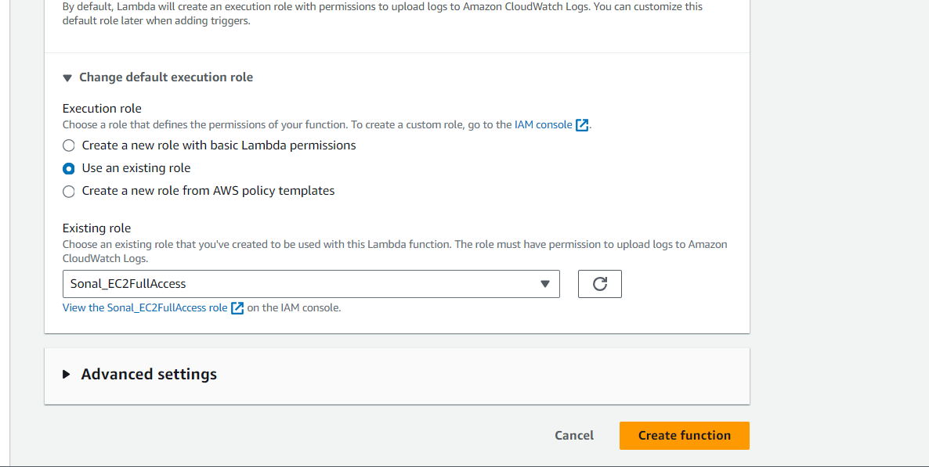

# Type the code for the Lambda function

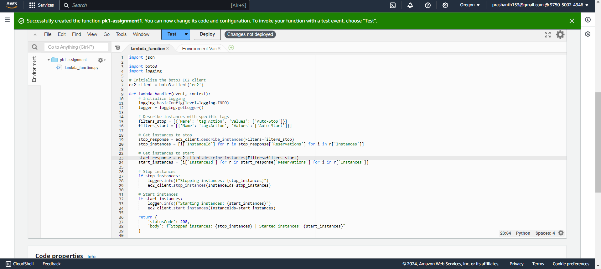

# EC2 Setup:

- Navigate to the EC2 dashboard and create two new t4g.nano instances (or any other available free-tier type).

- Tag the first instance with a key `Ac tion` and value `Auto-Stop`.

- Tag the second instance with a key `Action` and value `Auto-Start`.

I have used Boto3 to create the required instances and the code is there in the same folder.

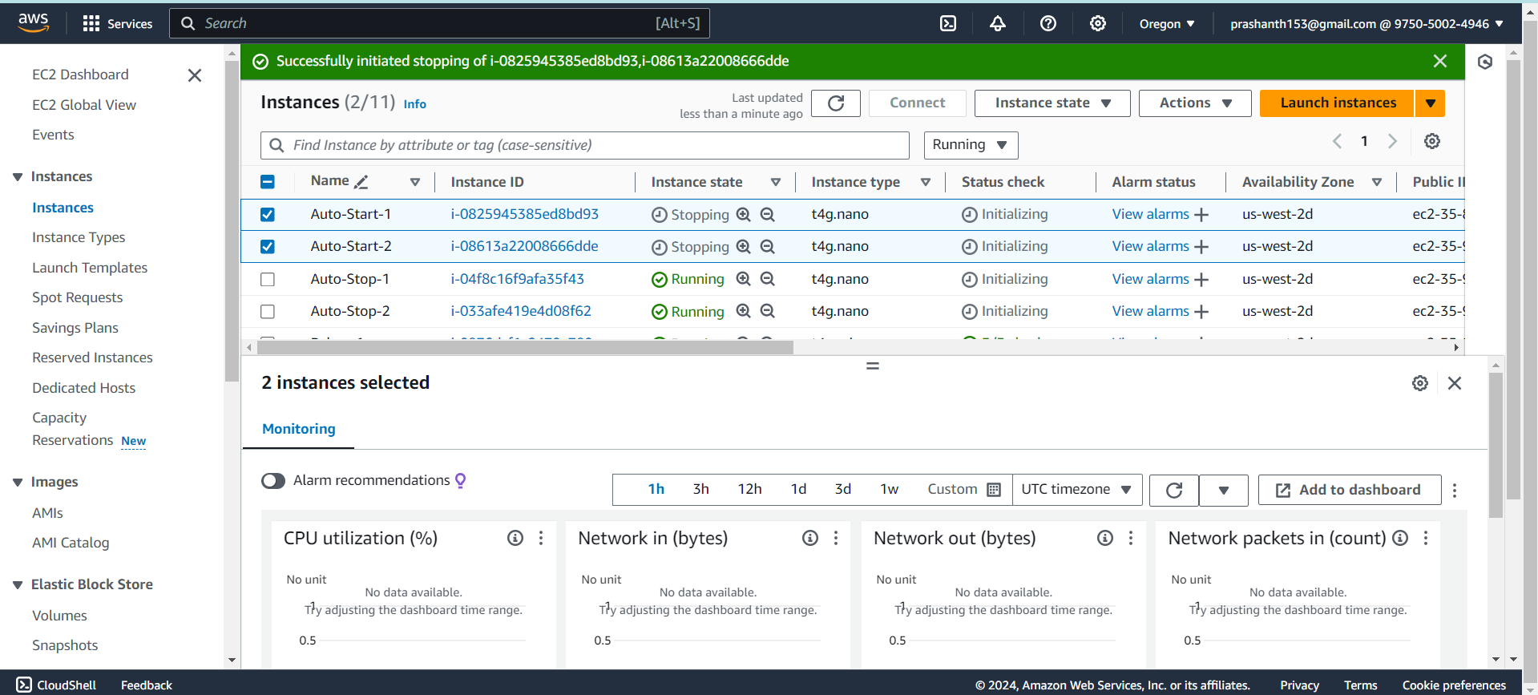

2 auto-stop are running currently

2 auto-start are stopped currently

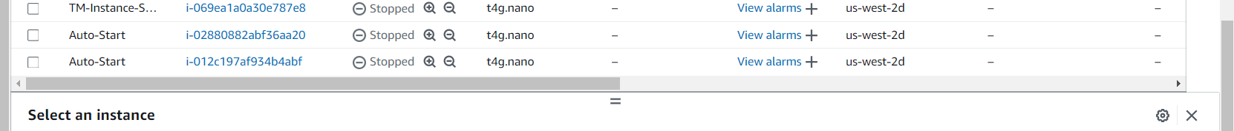

# Executing the Lambda function:

Event got executed successfully. After execution the following should happen

Auto-Start will be started

Auto-stop will be stopped

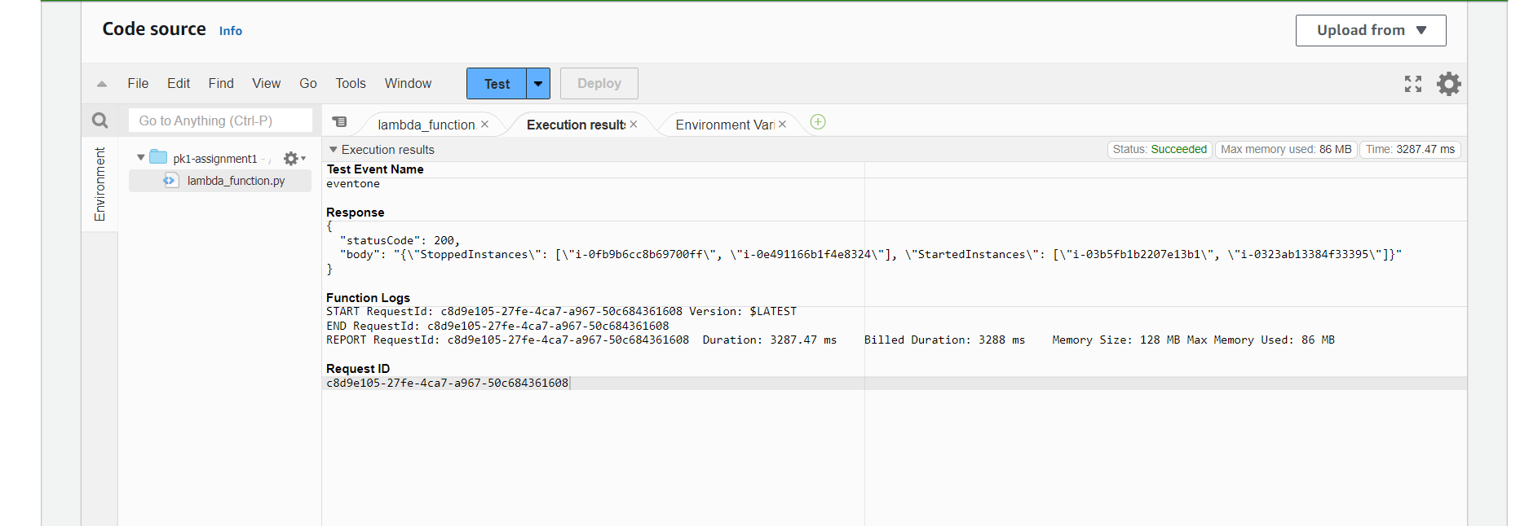

Output

Stopped instances were started again

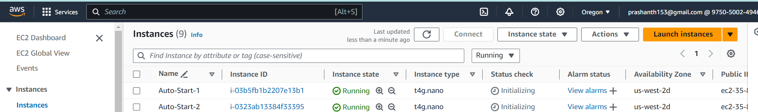

Started instances were Stopped again

